1. The equation for pair of FS (Fourier series) equations is defined as



*Where is the periodic signal in the time domain, is periodicity of the given function,  is frequency index*



If the given signal  is shown above, find FS and plot the signal, , when . Make sure that, the signal in the frequency domain is discrete (mag and phase)

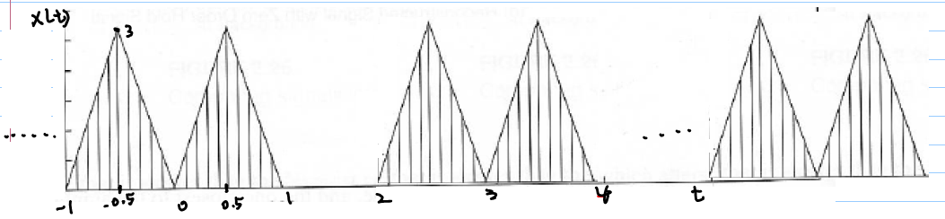

If the given signal  is shown above, find FS and plot the signal, , when . Make sure that, the signal in the frequency domain is discrete (mag and phase)